Chapter 1
The Fourth Paradigm and Machine Learning
1.1 Introduction to Fourth Paradigm
According to American physicist Thomas Samuel Kuhn; a scientific paradigm is a system of faith about physical reality. A scientific paradigm informs scientists about what it means to do science; what is a problem; what constitutes evidence; how to gather evidence and how to solve problems using the techniques and definitions supplied by the paradigm. His finding includes the following.
- Science undergoes periodic "paradigm shifts" instead of progressing in a linear and continuous way.
- Occasional invention of new theories and ideas unravels the old paradigm and establish a new way of doing science.
- Scientists can never divorce their subjective perspective from their work; thus, the comprehension of science can never rely on full "objectivity"[1, 15].
Thus scientific paradigms form the lifeline of all sciences and in course of time, it all converges to four paradigms which revolutionized science one by one. Let’s understand these paradigms through some examples.
For thousands of years people looked at sky for understanding the principles of celestial mechanics. Whatever they saw they noted down and shared the observations with others for confirmation and validation. This was the beginning of the first paradigm in science –observation and experimentation. The map of the sky made out of those observations guided them to navigate seas and discover new lands for trade and commerce. Isolated lands separated by thousands of miles started getting connected through sea routes and local knowledge about sky and native technology began to merge with that of the other countries.
Around 1600 A.D, Kepler and Newton, after going through thousands of years of observational notes about the sky and movements of planets across heavens made some generalization and formed the foundations of the theory of celestial mechanics. That led to the second paradigm in Science –Theoretical science i.e. set of rules that can explain all observed phenomena and predict the result of newly designed experiments. Since then, Theory and experimentation together advanced science leading to unprecedented knowledge revolution that the mankind has never seen before. This system outsmarted the system of observational and experimentation due to its impressive accuracy in explaining and predicting events.
But still, phenomena like climate change and galaxy formation was not amenable to study by theory or experimentation and it remained as a challenge. 1950s saw the development of electronic computers. Scientists were able to represent scaled down versions of weather models in the memory of computers and simulate the evolution of atmospheric conditions across the globe. One of the key observation came out of these studies was that ‘weather system’ is highly non-linear in nature i.e. evolution of weather over time is highly dependent on initial conditions and slight disturbance at any point in time will cause large deviations in its evolution at a later stage. Such systems are called chaotic systems and study of such systems can be made only by computer simulation. Nobel Prize winner Ken Wilson by then identified ‘computation and simulation’ as a third paradigm for scientific exploration. Detailed computer simulations capable of solving equations on a massive scale allowed scientists to explore fields of enquiry that were inaccessible to experiment and theory such as climate modeling and galaxy formation. Today, research and post graduate courses on computational sciences/ Engineering are part of most of the departments in US and European universities. In India, Indian Institute of Science-Bangalore, Amrita Vishwa Vidyapeetham-Coimbatore [14], NIT-Calicut, IIIT Hyderabad, IITM Trivandrum are some of the institutes which offer such courses at PG level. Computer scientists find themselves now in partnership with leading scientists in a wide array of disciplines - astronomy, biology, chemistry, hydrology, oceanography, physics and zoology- just to name a few-working on efforts such as drug development, alternative energy, health-care and cost containment.
1980s saw the rapid development of sensor technology. Instruments studded with vast array of sensors and embedded computers became very common. These inexpensive high-bandwidth sensors are transforming every field from data-poor to data-rich. For example, the Australian Square Kilometer Array of radio telescopes [2] shown in figure 1.1 (a), CERN’s Large Hadron Collider [3] shown in figure 1.1 (b) and the Pan-Starrs array of telescopes [4], are generating several petabytes of digital information each day.
`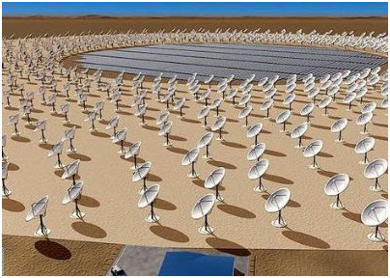 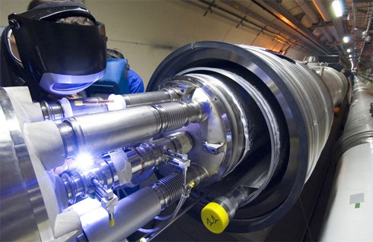
Fig 1.1 a) Large Square Kilometer Array b) CERN’s Large Hadron Collider
The sensor revolution helped scientists to collect massive amount of data and we have reached a point where even experts are drowning in data. Digital information is streaming in from all sorts of sensors, instruments and simulations, overwhelming our capacity to organize, analyze and store it.
This sort of data generation is happening in almost all fields of science. Thus management and processing of such huge datasets remained a problem due to restrictions in the speed of computes and available memory limitations. This dilemmatic situation propelled scientist to think out of the box and ended up in new data processing algorithms based on linear algebra and optimization which enabled the existing computers to process this data more efficiently and easily. Jeannette M Wing, assistant director of the Computer and Information Science and Engineering Directorate at the National Science Foundation called this the “Computational thinking” [5].
Even with the arrival of multi-core computing the data processing/storage problem existed due to the exponential increase in data. This high order of increase in data is not a challenge that we can address with patches and upgrades. So it prompted scientist to rethink the whole approach to data-intensive science. Then Microsoft scientist Jim Gray proposed what he called “the fourth paradigm” for scientific exploration [6]. Jim’s vision of new tools to analyze, visualize, mine and manipulate scientific data may represent the only systematic hope we have for solving some of our thorniest global challenges.
While the previous paradigms tried to explain all observed phenomena through theory or set of generic rules, which scientist derived over a period, the fourth paradigm insisted on deriving these rules automatically from the data obtained from sensors measuring the phenomena. Here relationship between and correlation of enormous amount of data is utilized to derive rules hence such rules can approximate the phenomena very closely.
Dr. Wing argues that ideas like recursion, parallelism and abstraction taken from computer science will redefine modern science. Implicit in the idea of a fourth paradigm is the ability, and the need, to share data. In sciences like physics and astronomy, the instruments are so expensive that data must be shared. Now the data explosion and falling costs of computing and communications are creating pressure to share all scientific data.
That marries well with the emerging computing “cloud,” approach driven by Microsoft, Google and others. Thus fuelled by the Internet; the shift is toward centralization of computing facilities. Both Microsoft and Google are hoping to entice scientists by offering cloud services tailored for scientific experimentation.
Dr. Jim Gray's call-to-arms was not to develop isolated powerful super-computers but “to have a world in which all of the science literature is online, all of the science data is online, and they interoperate with each other.” This dream is already close to a reality in some scientific domains like astronomy, where advanced instruments routinely generate petabytes of data available for public analysis. And with further developments in distributed and high-performance computing, with freely-available high-scale data management tools like Hadoop [7], and with advanced open-source data-analysis tools like R and Sage [8, 12] rapidly adapting to the scales of these data sets, the fourth paradigm is certain to become a mainstream reality in other scientific domains as well.
1.2 Characteristics of fourth paradigm
- Automated or semi-automated analysis of massive datasets
The Fourth Paradigm is characterized by the analysis of massive data sets in which, increasingly, new discoveries are made, not by hypothesis, but by data-driven computing. It’s the only way to even begin managing the Tsunami of data deluge. More importantly, if the data is free, open and transparent, it will be less likely to be burdened or corrupted even by big corporations, laboratories or governments. More importantly, it can speed the pace of research by facilitating the faster exchange of data between researchers, both inside and outside of formal scientific structures.
- Use of data mining algorithms
The probe for information from these massive datasets has to be done efficiently and that is where data mining algorithms come to picture. Data mining (knowledge discovery) is the process of analyzing data from different perspectives and hence squeezing out valid information from the data. The C4.5, The k-means algorithm, Support vector machines, The Apriori algorithm, The EM algorithm, PageRank, AdaBoost, kNN: k-nearest neighbor classification, Naive Bayes, and CART forms the top 10 data mining algorithms.
- Massive use of computers
Fourth paradigm involves massive use of computers. Here instead of developing programs based on known rules, scientists begin with data. They direct programs to mine enormous databases looking for relationships and correlations, in essence using the programs to discover the rules. Scientists consider the big data as part of solution, not as a problem. The fourth paradigm isn’t trying to replace scientists or other three methodologies but it demands a different set of skills. Without powerful machine learning methodologies, parallel multi-core computers and other supporting tools that manipulate data, it is difficult even for the highly trained subject expert to unearth the insights that are now starting to coming into focus.
- Emergence of Citizen-Scientists, open databases and tools
Recently in Kerala, India, AMRITA TV [13] channel introduced a programme called ‘Citizen-Journalist’ in which layperson are invited to participate in reporting burning issues in their locality. The programme was an instant success motivating other channels to introduce similar programmes. These programmes brought to light many corruption issues that is rampant in society. Now government officials and politicians will think twice when they take a bribe.
This is exactly one of the ways the fourth paradigm achieves faster breakthroughs in science. It allows the general public to interact with databases and contribute knowledge that will pave way for new discoveries.
1.3 Areas of applications
As discussed earlier the fourth paradigm methodology tries to understand scientific phenomena by querying out rules and relations directly from the data. But the availability of infinite pile of data has made the information extraction process difficult. It was then; the new idea of opening this vast database to the public where the citizens could contribute to and take from the repository any data. This concept coined the term “Citizen Scientist”. Here are some of the real-life examples where citizen scientist proved helpful.

    - Traffic-sensitive routing in North America
In Seattle - USA, volunteers with GPS devices in their cars helped gather critical data about local traffic routes simply by driving their cars. These methods were later extended to the task of predicting traffic on all streets in greater metropolitan areas and now enable traffic-sensitive routing for 72 cities in North America, available today in Bing Maps. This is achieved by analyzing massive quantities of data, which included information on the flow of traffic over highways, weather reports, accidents, local events, and other variables that had been gathered over several years. Soon all sorts of citizen-scientists in different fields will likely use devices as simple as cell phones or laptops to collect specialized information and analyze it.

    - Environmental Monitoring in Accra, Ghana
According to the World Health Organization more than 4.6 million people die annually from the direct impact of air pollution, which is more than who die in car accidents every year. But in many cases our knowledge of ambient air quality is limited to “a small handful of government installed environmental monitoring stations” that uses extrapolation to derive a single air quality measurement for an entire metropolitan region. This sparse sensing strategy does little to capture the very dynamic variability of air quality that depends on automobile traffic patterns, human activity, and output of industries.
This is where the potential of citizen generated environmental data comes handy. In this new strategy sensors are placed inside or along with GPS enabled mobile phones, which could gather information about air temperature, humidity, noise level and so on and then they send this information from their phones, by voice or text message, to a central repository.
A study was conducted for the same in Accra province of Ghana in Africa. Some taxi drivers and students were asked to carry certain sensors during their normal day to day activities. The sensing system automatically logs sensor data. At the end of each day, the pilot participants drop off their sensor packs at a central location where the data is extracted and the sensors recharged. This study showed large variations in visibility across smaller neighborhoods and different parts of the city which was not the case when sensing was done through limited number of static sensors placed at various parts of the city by the U.S. Environmental Protection Agency. Currently “Android” from Google - a software stack for mobile devices that includes an operating system, middleware and key applications, supports Citizen Mobile Environment Monitoring by allowing user to upload data to the internet. Colors in the figure 1.2 represent the individual taxi drivers’ readings while the size of the patch indicates the intensity reading of carbon monoxide during a single day. Red circles are locations where actual readings were taken. (The reader may refer attached CD for true color picture)
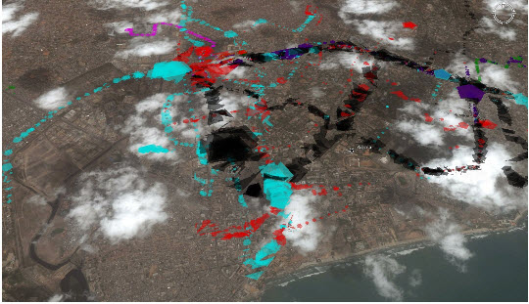
Fig 1.2: Intensity reading of carbon monoxide at Accra

The same method is also used to study the sound pollution in the cities. Here the software combines the sound-intensity data with the external GPS receiver data in order to generate a map of sound intensities encountered during a journey. One such map is shown in figure 1.3. (See CD for details)
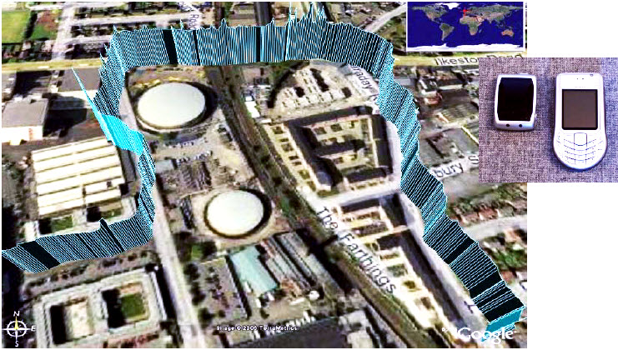
Fig 1.3: Google Earth Screenshot showing the sound intensity during a journey from home of the volunteer to his work.
    - WorldWide Telescope : Crowd sourcing in the heavens
The WorldWide Telescope (WWT) is a Web 2.0 visualization software environment that enables your computer to function as a virtual based telescope— which bring together imagery from the world’s best ground and space-based telescopes for the exploration of the universe. WWT blends terabytes of images, information, and stories from multiple sources into a seamless, immersive, rich media experience delivered over the Internet. Students of all ages will feel empowered to explore and understand the cosmos using WWT’s simple and powerful user interface. With the click of a mouse, or twist of a joy stick or Xbox controller, the presenter or student can fly through the universe; look at planets orbit the Sun from Pluto; see how the night sky appears from a distant star. Students can also participate in classifying galaxies by their shape. Thus “Citizens can do real science research”. Microsoft scientist, Hey points one such finding - the Hanny van Arkle’s object [9, 10] (also called Hanny’s voowerp), which is the bluest galaxy people have ever seen. The Arkle’s object is shown in figure 1.4. The galaxy was discovered by a Dutch schoolteacher (Hanny van Arkle), and it is now a target for exploration with the Hubble telescope.
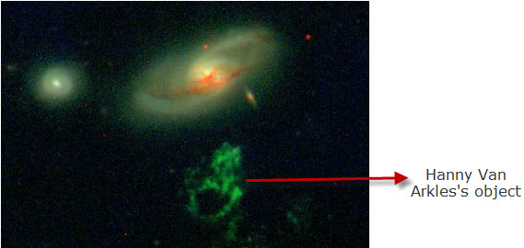
Fig 1.4: An unusually shaped object in sky discovered by Hanny van Arkle using WWT
During the year 2009, 50 million classifications of galaxies have been submitted on one million objects at galaxyzoo.org by more than 150,000 amateur astronomers from all over the world. The next stage of the project will ask volunteers for more detailed classifications, making it easier to identify more unusual objects such as Hanny's Voorwerp.
The mission of the WWT is twofold:
- To aggregate scientific data from major telescopes, observatories, and institutions and make temporal and multi-spectral studies available through a single, cohesive Internet–based portal

- To stimulate interest in science among younger generations, providing a compelling base for teaching astronomy, scientific discovery, and computational science
Microsoft Research has dedicated World Wide Telescope to the memory of Jim Gray, releasing it as a free resource to the astronomy and education communities with the hope that it will inspire and empower people to explore and understand the universe like never before.
Other citizen science projects include "Fold It” [11], a computer program for protein folding which actually forward research on genetics, proteins and molecular structure. Another project invites students to run scenarios about global warming on their home and classroom computers based on a wide range of starting parameters – by running these simulations, school kids can discover that global warming may evolve very differently based on minor changes in starting parameters.
    - Parallel programs, data storage , data-fusion and curation
The stress this kind of ambitious project puts on every aspect of current technology—processing power; demand for parallel programmers; and data storage, curation, and publishing—is enormous. Unless curation of the data is actually built into a project’s design, for example, the scientists involved usually try to figure it out ad hoc, which tend to lead to brittle, solutions that don’t scale up. Scientists and policy makers, however, do not have the luxury of waiting until everything is figured out before taking action on urgent problems such as climate change or water shortages or planning for hurricanes or tsunamis.
Consider the plight of California, where the population is projected to increase from about 38 million today to more than 50 million by 2040. Says Jeff Dozier, a professor in the School of Environmental Science and Management at the University of California, Santa Barbara: “The availability of water drives California’s economy. Historically, we’ve tried to manage the supply of water to meet demand. We may not be able to do that anymore. Everyone would love a reliable, uniform supply, but that’s not what nature gives us. We will need much better technology to predict the amount of water we will have in a given year.”
Predicting water stores from snowpack is a much more difficult problem than it might appear, Dozier explains. Satellites collect huge volumes of data on snowpack, but they are still insufficient because they mainly reveal the snow’s surface characteristics. To manage runoff, we need to know the “water equivalent,” or the amount of water that would result from snowmelt. We can estimate the water equivalent from the weight of the snow, but that is difficult to measure across large stretches of variable terrain. The challenge: How do scientists combine data from satellites and surface measurements with information on economics and governance to better estimate, calibrate, and manage water supplies? In California alone, there are at least 400 different agencies that manage water. Microsoft is working with scientists at the University of California, Berkeley, and the Lawrence Berkeley National Laboratory to acquire and curate historic hydrologic data so that they can be used more effectively with data from new sensor networks to create better prediction models.
    - Ground water management – In water scarce countries
It is a fact that the earth is facing a major threat to its ground water resources due to its depletion and pollution. For the same reason, ground water is continuously monitored to determine annual and long-term changes of groundwater in storage, estimation of recharge rates, and determination of direction and gradient of groundwater flow, to understand how aquifer systems work, to gain insight for well-construction and where to set pump bowls for efficient extraction. Presently groundwater monitoring is done using remotely sensed data from satellites and aerial photographs which observes the topography, soil profile, geology, aquifer characteristics, land-use pattern, source of pollution etc. to predict the groundwater level. The predictions done using this information are not usually accurate. To improve the accuracy the water level and quality information from selected well are also obtained either manually or using wireless sensors. Such information is collected every day. Even after having all the data, the prediction of water levels and quality cannot be done using an interpolation [17]. This is where the fourth paradigm techniques help. Using data mining it is possible to find the pattern that the water table follows in various seasons using a prediction model. Even the effect of population, festivals, precipitation etc. can be incorporated in the prediction model.

    - Air pollution detection in UK
The main Air pollutants in England and Wales are: Carbon monoxide, Nitrogen dioxide, Sulphur-di-oxide, Lead, Ground level ozone, other small particles. Air pollution detection in UK was originally done to confirm the original assessment of air quality, and to calculate more accurately how much of an improvement in air quality would be needed to deliver the air quality objectives within the “Air Quality Management Area”. The impact of road traffic on local air quality and individuals exposure to air pollution is a major public policy concern. Research for this requires increasingly detailed knowledge of how traffic-generated pollution behaves in the urban environment with factors such as street and building design, vehicle braking, accelerating patterns, individual traveler’s decisions, local weather conditions etc.
But accurate measurement of such parameters is not possible with data from limited number of sensor place in selected areas of the city. Accuracy can only be achieved with the availability of large amount of such information which only the citizens can provide. Cyclists and pedestrians use mobile phones to capture and contribute information while walking or riding in Cambridge, which is then used to build a larger picture of pollution round the city.

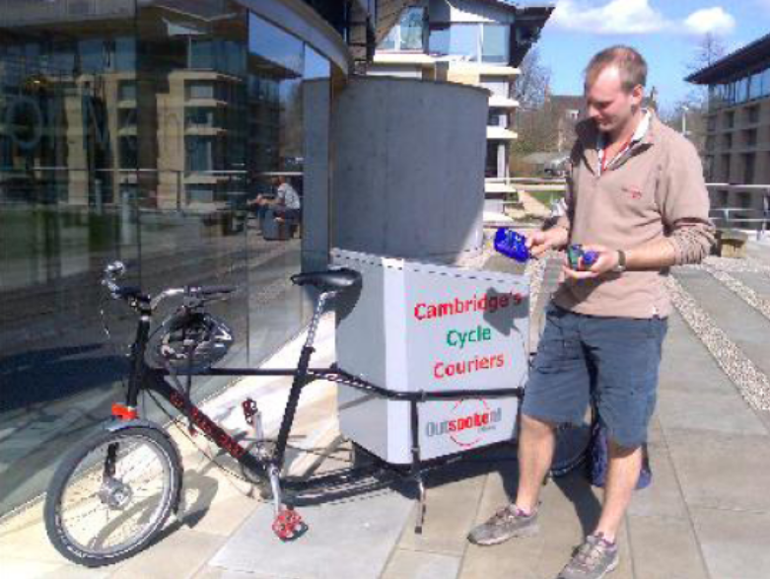
Fig 1.5: A cyclist holding pollution sensors

As the fourth paradigm says, once the data (values of parameter which determine air pollution such as amount of CO, SO2 etc) of pollution is obtained it is always possible to find the relationship within the various polluting parameters. And thus it was possible to predict with considerable accuracy various causes and effects of pollution [16]. For example effect of placing an industry at a particular area on pollution levels can be studied virtually before giving sanction for industries.

    - Personal Health Monitoring with smart phones
Here a person’s physiological information such as his/her heart rate, details of ECG, breathing rate, body temperature, biochemistry and other activities are recorded and stored or continuously transmitted to a clinic in order to facilitate improvements in his/her health, or to watch for a gradual or sudden decline in health. In this way people with long term health issues, such as chronic heart, kidney or liver failure, diabetes and so on, can either gradually improve their health, or can be kept at home instead of in hospital yet still have high quality health supervision.
Heart monitoring is done through the help of wireless wearable bio-sensors which continually send cardio data(Heart rate, blood pressure, sugar level) to the a GPS enabled smart phone which re-transmits these information to a central clinical database.

Again Diabetes management is achieved through wireless transmission of blood glucose readings to a central web-based database, allowing an accurate diary to be kept. This information will help in analyzing the sugar level variation patterns and hence sometime reaches a position to predict the sugar level variations.
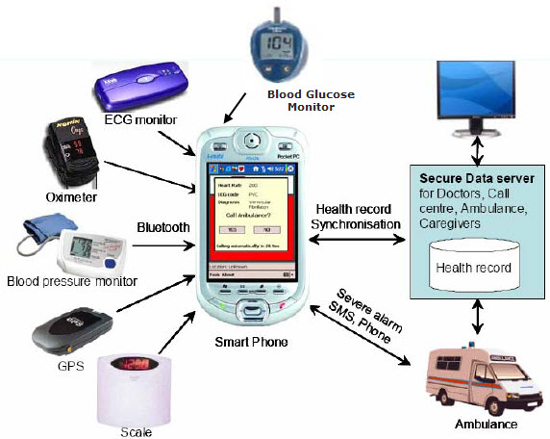
Fig 1.6 : Health monitoring sensors within smart phone
The figure 1.6 shows the various health monitoring sensors that can be attached with smart phones. Apart from smart phones some of the most advanced health monitoring systems include smart shirts, chest bands and watches, heart rate watches, accelerometers for activity monitoring and shoe pressure and activity measurement [25].
    - InSTEDD (Innovative Support to Emergencies, Diseases and Disasters)
It is a non-profit group based in California, which promotes the use of mobile phones to improve on the ability to respond to disasters. It was launched with seed money from Google’s philanthropic arm and the Rockefeller Foundation in late 2007.

It turned mobile phones into sensors on a global data-collection network. A sensor inside phones, or one attached to them, could gather information about temperature, humidity, noise level and so on. This can be a used to gather data quickly during a disaster-relief operation, for example, or when tracking the outbreak of a disease. Engineers, biologists, sociologists and aid-workers are now building systems that use handsets to sense, monitor and even predict population movements, environmental hazards and public-health threats.

The organization released GeoChat, a suite of open-source software to share, aggregate and analyzes data from mobile phones. In Cambodia, Health-workers send text messages, containing observations and diagnoses, to a central number instead of recording information on scraps of paper, which would take days to reach higher-ups and trigger an alarm, the cycle-time has been reduced to days or even hours thus enabled a quick response to any outbreak of avian flu, cholera, malaria or dengue fever. GeoChat has been officially adopted by the six countries which share a border in the Mekong Basin, including Myanmar and Yunnan province in China, establishing a flow of real-time disease data from villages in the region to each country’s health ministry

    - ArtEmotion Maps
Over the last five years, over 2000 people have taken part in community mapping projects in over 25 cities across the globe using ‘Bio Mapping tool’. The Bio mapping tool allows the wearer to record their Galvanic Skin Response (GSR), which is a simple indicator of their emotions in conjunction with their geographical location. By sharing and reflecting on this data, it is possible to construct maps that visualize where we as a community feel stressed and excited. Through this process communal Emotion Maps of lots of people's emotion data are constructed which are packed full of personal observations and highlight the issues that people feel strongly about [26].

    - Semantic enhancement in text
Semantic Web is a group of methods and technologies to allow machines to understand the meaning - or "semantics" - of information on the World Wide Web. The term was coined by World Wide Web Consortium (W3C) director Tim Berners-Lee. He defines the Semantic Web as “a web of data that can be processed directly and indirectly by machines.” For technologies such as Resource Description Framework (RDF), RDF Schema (RDFS) and the Web Ontology Language (OWL) the key objective is to determine the meaning of the text or data, hence project connected terms from the text/data for the user. The availability of machine-readable metadata would enable automated agents and other software to access the Web more intelligently. However Semantic Web as a global vision has remained largely unrealized and its critics have questioned the feasibility of the approach [23].

An example of such a fully automated tool for annotation of scientific terms is ‘EMBL Germany’s Reflect’ [30], which operates as an external service on any Web page or as a browser plug-in. It tags gene, protein, and small molecule names, and the tagged items are linked to the relevant sequence, structure, or interaction databases. In a further thought experiment, Shotton et al. [24] marked up an article by hand using off-the-shelf technologies to demonstrate a variety of possible semantic enhancements— essentially a minimal set that would likely become commonplace in the near future. Figure 1.7 shows the semantically enhanced part of text document - PLos Neglected Tropical Diseases.

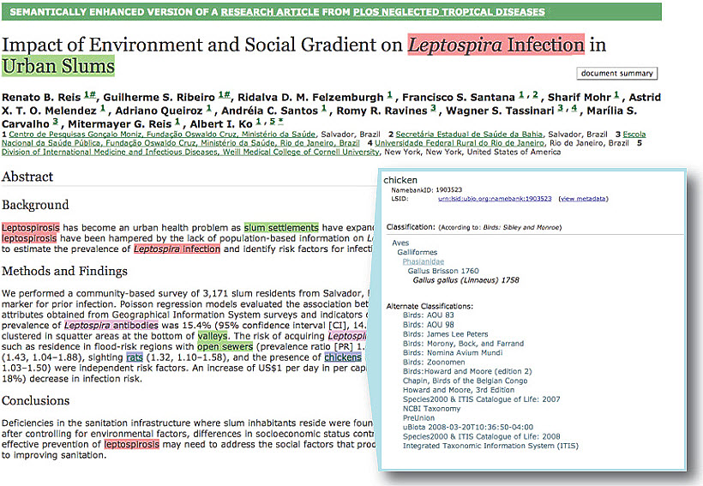
Fig 1.7: Semantically enhanced version of a research article from PLos Neglected Tropical Diseases
  - New Fourth paradigm based projects
    - Sensing the Oceans
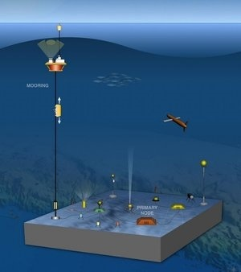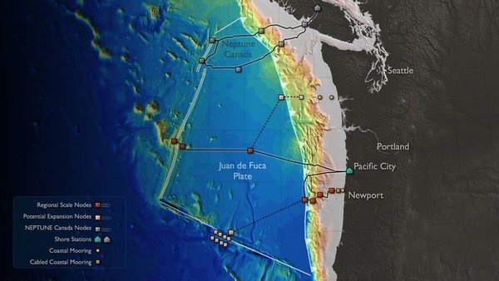
Fig 1.8: Underwater network of high-definition cameras and sensors [reprinted with permission from [29]]

Oceans cover about 70% of the earth surface and still, what we know about oceans and its processes is just the tip of the iceberg. The absence of by heat, light from the Sun and also extreme pressure forbids humans from visiting its depths. Since 19th century attempts were made to study the ocean floors and structures. But scientists were all ignorant and equally cautious about what is happening in there.
In 1925, the German vessel Meteor sailed around the Atlantic Ocean taking detailed measurements of the ocean floor using echo sounding equipment. These voyages revealed new information about the shape and structure of the ocean floor. In 1948 Swiss physicist Auguste Piccard dives in his newly designed vehicle known as a bathyscaph. It is the first untethered craft to carry people into the oceans deep waters, in 1951 the Deepest Ocean Point (Marianas Trench) was found, in 1955 Magnetic striping of ocean floors discovered and 1977 witnessed the discovery of deep sea Hydrothermal Vents. Now to an extend even sea floor mapping from space is possible (using Geosat satellite radar altimetry data). Still most of the deep oceans remain unexplored [27].
According to findings of Deep Ocean Exploration Institute (DOEI), the world's oceans and the Earth's crust and mantle beneath them offer some of the best windows into how our planet works and the processes that drive chemical, biological and geological activity which sustain and shape our dynamic world [28]. It was shown that Earth and its oceans are not a fixed and static surface veneer, but rather components of a dynamic, interacting system, all set in motion by underlying forces at work in deeper layers of our planet.
With the advancement in technology we now have the instruments and capabilities to explore the planets deep blue part. But still the problem is that; there is a lot to explore. This is where the fourth paradigm methodologies come with the helping hand.
An ambitious environmental project is now under construction beneath the cool Pacific waters west of Washington State and British Columbia. On a patch of the Pacific’s floor, oceanographers involved with the U.S. National Science Foundation’s $600 million Ocean Observatories Initiative (OOI) have mapped out a network of nodes that is designed to offer a USB for the ocean. OOI will lay 1,500 miles of cable to and around the patch, providing power, internet access, and the ability to record and time-stamp data on phenomena scientists will study with all sorts of devices, ranging from simple temperature sensors to remote-controlled robots to state-of-the-art gene sequencers. The artistic representation of this underwater sensor network is shown in figure 1.9. The project aims to involve scientists from all over the world.
The amount of information OOI will generate is so large and hence an effective management and processing methodology was required. It was then the idea of sharing the data with the public was borrowed from the concept of fourth paradigm. The data was stored in a shared computing cloud hence making them accessible to the any scientists, students, and interested citizens of the world. Any new finding by these people will be uploaded to the central server and will be publicly visible. Real-time video and new data visualization tools are made available which will allow students, educators, and the public at large to watch these events unfold and, in some cases, even conduct their own experiments. Thus it would be true to say that the internet will emerge as the most powerful oceanographic tool on the planet soon [29].
OOI is also helping in unleashing the creativity of oceanographers worldwide, who are developing new kinds of instruments to plug into this undersea lab. One of such creative thinking resulted in putting ‘DNA sequencer’ which will operate unmanned in underwater at the same time filters in local creatures, capture and sample their DNA, and then send the results to scientists on shore. This DNA data will be accessible from the internet to any researcher interested; hence supporting research and development [29, 19].
    - Individual Health Models
From the previous examples you might have understood that, the fourth paradigm sciences can be used to study/understand/predict any event; the only requirement being availability of continuous data channels. From these data information about the nature/attributes of event can be found out.
If this is the case, we can apply the same for analyzing/ predicting the health of an individual. The exiting healthcare methodology is still in the way to completely realize the third paradigm shift - acting upon the evidence i.e. doctors understand the illness based on the current symptoms and patients previous health records. Here especially in regard to capturing the complexities of clinical practice in a digital record and making some aspects of healthcare computable. In the case of fourth paradigm healthcare system, a individual’s health data are aggregated from multiple sources and attached to a unified model of that person’s health. Here the details about the individual’s health will be collected by using sensors placed in his body. This information collected at different times along with previous health records can be utilized to build an ‘Individual Health Model’ - the electronic representation of an individual’s health as directly measured or inferred by statistical models or clinicians.
Doctors can then interacting with a patient’s health model ad hence achieve a more integrated view of different specialist treatment plans than they do with health-care records alone. The health-model is not only a statistical tool to support diagnosis and treatment, but it is also a communication tool that links the patient and the patient’s elected network of doctors and other trusted caregivers—for what-if treatment discussions [29].
Such health-models would not involve a molecular-level simulation of a human being (which we view as implausible) but would instead involve a unified statistical model that captures current clinical understanding as it applies to an individual patient. This paradigm can be extended to communities, where multiple individual health-models interact with a community health model to provide a unified model of the community’s health. Such a community health model could provide relevant and timely information for use in protecting and improving the health of those in the community [18].
    - Vaccine for HIV
The human immunodeficiency virus (HIV) continues to prove a difficult virus to pin down because it mutates so rapidly—a trait which, so far, has made an effective vaccine for this often-deadly condition impossible to develop. According to Microsoft’s David Heckerman, “In several years in a single patient, HIV mutates about as much as the influenza virus has mutated in its known history and that is why developing a vaccine to thwart it has been so difficult.”
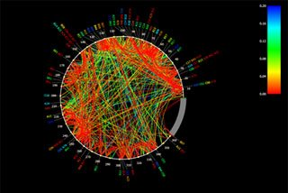
Fig 1.9: The PhyloD Viewer draws proteins as circles to reveal mutation patterns
that could aid in HIV vaccine design.
A first step in overcoming this challenge is to identify consistent patterns in viral adaptation. Tools such as PhyloD Viewer, and Phylo Detective can be used to identify and visualize HIV co-variation and adaptation. By identifying patterns and constraints in HIV evolution, scientists are able to focus on HIV's weaknesses, with the goal of designing a vaccine that will be resistant to HIV mutation. The arcs in the circle (Figure 1.9), developed with the PhyloD Viewer, represent how HIV in a single patient is connected to itself as parts of it mutate. This research delivered a statistical approach that could help further research into HIV mutation. Once the way that HIV adapts to the human immune response is found out, it could pave the way for HIV vaccine design [22]. Scientist are analyzing data about individual viral mutations in thousands of subjects, trying to zero in on the elements of the virus that are vulnerable to attack by the immune system. By creating a vaccine that can trigger a person’s own immune system to attack those elements, they hope to stop the virus in its tracks.
    - UID project in India
Unique Identification Authority of India (UIDAI) was constituted in January 2009 as an attached office of the Planning Commission. The UID brand was renamed ‘Aadhaar’ meaning foundation in April 2010. The logo of ‘aadhaar’ (finger print within a rising sun) adopted after a nationwide contest, allegedly represents a new dawn of equal opportunity for each individual, a dawn which emerges from the unique identity the number guarantees for each individual.
According to the UIDAI, the UID project would provide unique numbers to all residents of India. Apart from providing identity, the UID will enable better delivery of services and effective governance. In becoming a single source of identity verification, it could enable the easier roll-out of wide number of services such as bank accounts, passports, driving licenses, and LPG connections. Proof of identity and greater financial inclusion could lay the basis for checking fraud and corruption, avoiding duplication and targeting intended beneficiaries in a range of programs such as the NREGS and the PDS. The first set of UID numbers will be issued between August 2010 and February 2011. Thereafter, 600 million UID numbers will be issued in the next five years.
The UIDAI proposes to collect the data through various agencies of the Central and the State Governments and others who, in normal course of their activities, interact with the residents. These entities are described as “Registrars” of the UIDAI. Examples of such Registrars at the State level are the Departments of Rural Development (for MNREGA) and Public Distribution and Consumer Affairs (for PDS). At the central level these entities could be Banks, Life Insurance Corporation and Oil Marketing Companies. As the NPR exercise is also going on, the Registrar General of India will also be an important Registrar for the purpose of collection of demographic and biometric data for the project.

    - Medical database for remote areas in India
Yet another breakthrough was achieved with the availability of large medical databases to the public. In remote villages which lacked medical facilities even nonmedical personals were enabled to diagnose diseases with the help of cell phones. All that a person need to do is to dial into a medical diagnostic system (which is configured/trained using the vast medical database information) where they will be asked to fill in answers to a set of questions and receive valuable diagnoses on the spot. This system could someday be used to track and study the spread of diseases, particularly infectious ones. With large numbers of people performing quick diagnostics that feed into a database, public officials and health care workers can see where outbreaks are occurring, how fast they are moving, and what kind of symptoms are appearing. Machine learning can enter the loop in real time, constantly comparing every new case with every other case of this and other infectious outbreak. They can also help in looking for patterns that might aid prevention efforts [6].
    - Virtual deep ocean – for next-generation scientists or citizens

As we saw in section 1.4.1 of this chapter, deep oceans are lying there yet to be explored. The oceans have had a long and complicated history, producing today’s immensely complex system in which thousands of physical, chemical, and biological processes continually interact over many scales of time and space as the oceans maintain our planetary scale ecological balance. It is also a found that the world's oceans and the Earth's crust and mantle beneath them offer some of the best windows into how our planet works and the processes that drive chemical, biological and geological activity which sustain and shape our dynamic world. Attempts are continually done to explore its complexity but still they have been chronically under-sampled due to its vastness.
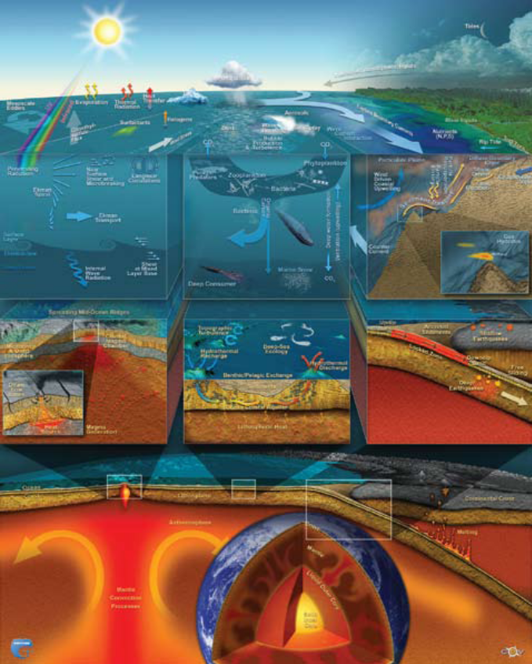
Fig 1.10: An artistic representation showing the complexity of the ocean [reprinted with permission from [29]]

As we saw in the previous section, wiring the ocean floor was one prospective ongoing project. Likewise many new innovative technologies and instruments are utilized to simultaneously and continuously sense the different processes happening in remote volumes of the ocean. Phenomena’s like underwater volcanic eruptions, large submarine slumps, big earthquakes, giant storms, and other complex phenomena that have been inaccessible was made a available to scientific study with the help of rapid reconfigurable sensor arrays linked to the Internet via submarine electro-optical cables [29]. Such capabilities would enable mankind to understand the complex oceanic ecosystem and also predicting their future.
For this the primary requirement is oceanic data collection. Large arrays of heterogeneous sensors operated by many investigators over periods of decades to centuries helped in obtaining simultaneous and in real time oceanic data over many scales of space and time, regardless of the depth, energy, mobility, or complexity of the processes involved. The collected data is then archived, visualized and compared to create simulation models which then can be provided to the citizen scientist for analysis [29].

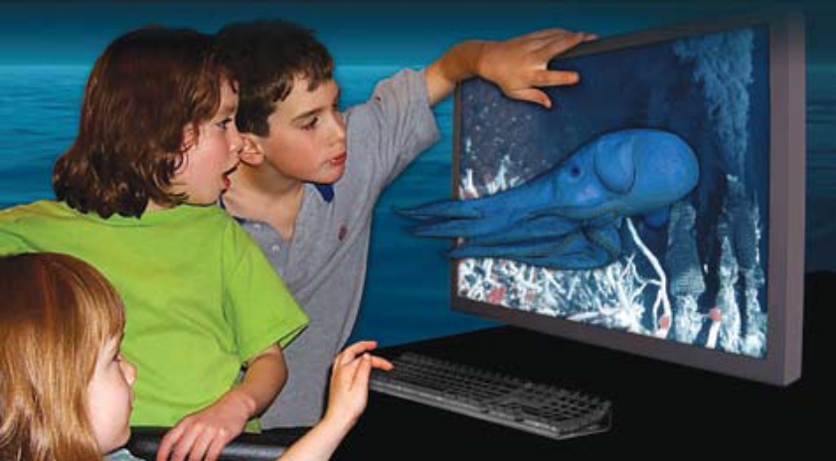
Fig 1.11: This virtual picture shows a deep ocean octopus, known as Grimpoteuthis, and a portion of a submarine hydrothermal system on the Juan de Fuca Ridge. [reprinted with permission from [29]]

This approach offers three main advantages [20]:
(1) The models progressively emulate the measured reality through constant comparison with data to capture the real behavior of the oceans in “model space” to move toward more predictive simulations.
(2) When the models and the data disagree, assuming the data are valid, we must immediately adapt at-sea sensor-robot systems to fully characterize the events that are unfolding because they obviously offer new insights into the complexities we seek to capture in the failed models.
(3) By collecting and combining all observations and measurements in coherently indexed time and space frameworks, we can allow many investigators (citizen scientists) to examine correlations among any number of selected phenomena during, or long after, the time that the events or processes occur.
Real-time displays of 3-D HD video shown in figure 1.11 will be routine within 5 years. If the archived data are immediately and widely available via the Internet, the potential for discovery rise substantially because of the growing number of potential investigators who can explore a rapidly expanding spectrum of “parameter space”[20].
    - Machine translation - English to Indian Languages
Machine translation (MT) enabled computer to translate between natural languages, in either text or speech while preserving the meaning and interpretation.MT technology has gone through several paradigms from its very beginning in the past half century, including word-to-word direct translation, rule-based transfer approach, inter-lingua approach and knowledge-based machine translation (KBMT). But above approaches couldn’t provide an efficient translation system. It was machine learning approaches which brought in a breakthrough in the idea of machine translation.
In general, the translation process in traditional MT involves three subtasks namely, analysis, transfer and generation. Analysis deals with the transformation of the source utterances into a pre-defined format of internal representation, through morphological processing, part-of-speech (POS) tagging, syntactic parsing, semantic analysis, etc. Transfer works to convert the representation of the source language into that of the target language. Except for the inter-lingua approach, there used to be different representations for different languages. Generation, or synthesis, is concerned with the derivation of target utterances from the representation, observing necessary syntactic, semantic and pragmatic constraints. Each step in these processes involves, inevitably, many ambiguities, and each kind of ambiguity needs a large volume of knowledge for comprehensive disambiguation. It is machine learning (data mining) approaches which facilitate the translation process. They extract out rules from the large volume of knowledge and use these rules while translation [21].
1.5 Summary
The scientific world had undergone four paradigm shifts in its lifetime. And it is the fourth paradigm shift that is going to revolutionize this world to a greater extend. Data mining stand as the backbone for this revolution. With the advancement in sensor technologies data collection has become very cheap and all that was required was to extract the information out of it. The data mining methodologies aim at extracting this information from huge heaps of raw data. The idea of opening up this data to the public was the best part in the fourth paradigm techniques. It exponentially increased the rate of information extraction and at the same time kept these extracted information public. The fourth paradigm methodologies would enable mankind to do thing which were thought as extremely difficult or impossible before. As an outcome this paradigm shift, A farmer in the country region will be happier than before, for he can predict, the outcome of his cultivation, the best crop he might cultivate at that season etc. using readily available data mining tools. For example decision tree data analysis tool can be applied for many day to day tasks and the output of the decision tree is intelligible to any lay person. So what is required is popularization of simple as well as complex data mining tools that are freely available. This text book is the first ever attempt to make it a reality. Forthcoming chapters explain how data mining can be done in spreadsheet as well as how to call professional data mining tools in excel.
References

[1] “The Mother Paradigm - the First Principle of Science”: http://godsriddle.com/paradigm/mother-paradigm.html, Feb 14, 2009

[2] The Square Kilometer Array – Exploring the universe with the world’s largest radio telescope: http://www.skatelescope.org
[3] European Organization for Nuclear Research, “The large Hadron Collider”: http://public.web.cern.ch/public/en/lhc/lhc-en.html

[4] Wikipedia, “Pan-STARRS”: http://en.wikipedia.org/wiki/Pan-STARRS, Nov 12, 2010.
[5] Carnegie Mellon, Center for Computational Thinking, “What is Computational Thinking”: www.cs.cmu.edu/~CompThink.
[6] Tony Hey. “The Big Idea: The Next Scientific Revolution”: http://hbr.org/2010/11/the-big-idea-the-next-scientific-revolution/ar/1, Nov 2010.
[7] Hadoop Wiki, “Apache Hadoop”: http://wiki.apache.org/hadoop, Jan 22, 2011.
[8] Institute for Statistics and Mathematics, “The R Project for Statistical Computing”: www.r-project.org.
[9] BBC Mobile News, “Teacher finds new cosmic object”:
http://news.bbc.co.uk/2/hi/science/nature/7543776.stm, Aug 05, 2008.
[10] Wikipedia “Hanny’s Voorwerp“: http://en.wikipedia.org/wiki/Hanny’s_Voorwerp
[11] foldit_{BETA}- Solves puzziles for science: http://fold.it/portal
[12] Sage - open source mathematics software: http://www.sagemath.org
[13] Amrita Television: http://www.amritatv.com
[14] Amrita CEN - Center for Computational Engineering and Networking: http://cen.amritafoss.org,

[15] Wikipedia, “Thomas Kuhn”: http://en.wikipedia.org/wiki/Thomas_Kuhn, Feb 16, 2011

[16] Cambridge City Council, ”Air pollution in Cambridge”: http://www.cambridge.gov.uk/ccm/content/environment-and-recycling/pollution-noise-and-nuisance/air-pollution/air-pollution-in-cambridge.en

[17] Allan Fulton, Toccoy Dudley and Kelly Staton, “Groundwater level monitoring: What is it? How is it done? Why do it?”

[18] Iain Buchan, John Winn, Chri s Bishop “A Unified Modeling Approachto Data-Intensive Healthcare”, Microsoft Research

[19] “Wiring the ocean: researchers build world’s first permanent undersea broadband remote sensing network”: http://www.smartplanet.com/business/blog/smart-takes/wiring-the-ocean-researchers-build-worlds-first-permanent-undersea-broadband-remote-sensing-network/9419
[20] John R. Delaney¹, Roger S. Barga², ”A 2020 Vision for Ocean Science”, University of Washington¹, Microsoft Research²

[21] Chunyu Kit, Haihua Pan and Jonathan J. Webster, “Example-Based Machine Translation: A New Paradigm”, Department of Chinese, Translation and Linguistics, City University of Hong Kong

[22] Microsoft Research, “How Microsoft Technology and Research Are Helping Create a Clearer Picture of HIV”: http://blogs.msdn.com/b/msr_er/archive/2010/12/14/how-microsoft-technology-and-research-are-helping-create-a-clearer-picture-of-hiv.aspx, Dec 14, 2010

[23] Wikipedia, “Semantic Web”: http://en.wikipedia.org/wiki/Semantic_Web

[24] D. Shotton, K. Portwin, G. Klyne, and A. Miles, “Adventures in Semantic Publishing: Exemplar

Semantic Enhancements of a Research Article,” PLoS Comput. Biol., vol. 5, no. 4, p. e1000361,

2009, doi: 10.1371/journal.pcbi.1000361.
[25] Proetex,“Personal Health”: http://www.proetex.org/final%20proetex%20learning/personal_health.htm
[26] Christian Nold, ”Emotional Cartography - Technologies of the Self “: http://emotionalcartography.net

[27] Ocean Exploration Timeline: http://www.seasky.org/oceanxp/sea5a3a.html
[28] Investigating Earth's Dynamic Processes: http://www.whoi.edu/page.do?pid=7400, Woods Hole Oceanographic Institution.
[29] Tony Hey, Stewart Tansley, and Kristin Tolle, “The Fourth Paradigm Data-Intensive Scientific Discovery”
[30] D. Shotton, K. Portwin, G. Klyne, and A. Miles, “Adventures in Semantic Publishing: Exemplar
Semantic Enhancements of a Research Article,” PLoS Comput. Biol., vol. 5, no. 4, p. e1000361,
2009, doi: 10.1371/journal.pcbi.1000361.

